LEVIN FORMAL 2018 –
AMENDED APRIL 2018

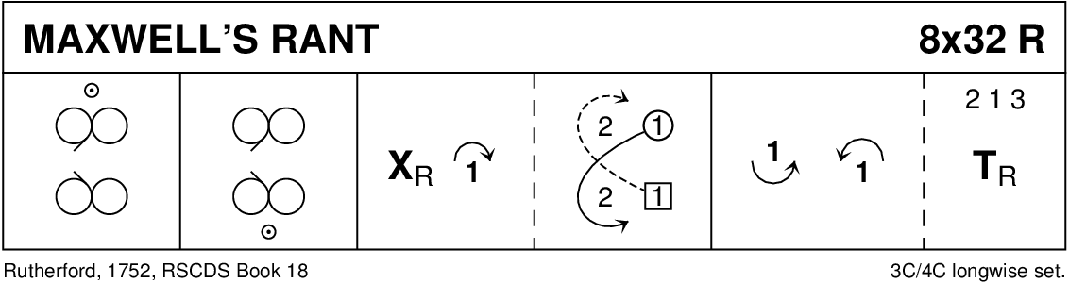

MAXWELL'S RANT (R8x32) 3C (4C set) Rutherford RSCDS Bk 18
1- 8 1s cross down to dance reflection reels of 3 on opposite sides
9-16 1s cross down to dance reflection reels of 3 on own sides
17-24 1s cross RH, cast to 2nd place & dance 1/2 Fig of 8 round 2s
25-32 1s lead down between the 3s, cast up to 2nd place & 2s+1s+3s turn partners RH

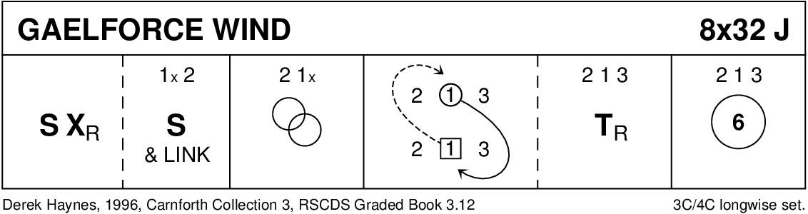

GAELFORCE WIND (J8x32) 3C (4C set) Derek Haynes Carnforth Collection 3
1- 8 1s set, cross RH, 1s+2s Set&Link (Ladies face out)
9-16 2s+1s Men's Chain
17-24 1s ½ Figs of 8 (L round 2s and M round 3s), 2s+1s+3s turn RH and open into
25-32 2s+1s+3s circle 6H round and back
(MINICRIB, Dance Crib compiled by Charles Upton, Deeside Caledonian Society, and his successors)

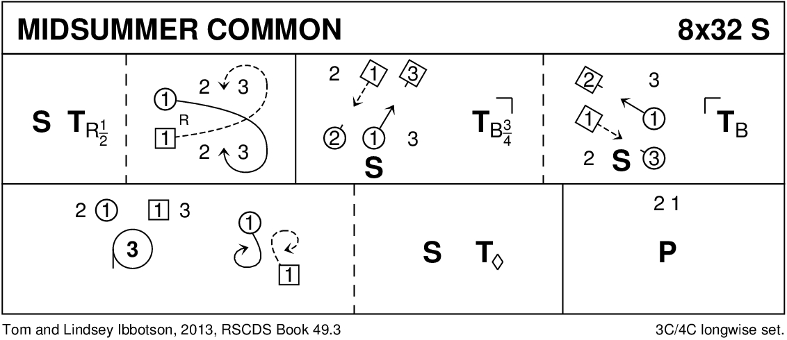

MIDSUMMER COMMON (S8x32) 3C (4C set) Tom and Lindsey Ibbotson RSCDS Book 49
1- 8 1s set, ½ turn RH, lead down, cross below 3s, cast up to 2nd place own sides (2s step up 5-6)
9-16 1s set advancing to 1st corners and turn 1st corners 2H finishing 1M between 3s, 1L between 2s. 1s set advancing to 2nd corners, turn 2nd corners 2H and retain 2nd corner's LH
17-24 1M+2s also 1L+3s circle 3H round to Left, 1s pull back RSh to face up/down set. 1s set, petronella turn to 2nd place own sides
25-32 2s+1s dance Poussette

A Tizzy of Tadpoles (R4x32) 4C (4C set) K Deroles NZBranch 50th Anniversary
1-8 1s turn R, 1W leads 1M to 3rd place opp sides. Meanwhile 4s turn R, 4M leads 4W to 2nd place opp sides. 2s step up, 3s step down
9-16 1s+4s set facing diagonally in, each pulls Rsh back to change places with corner person behind. Corners (2s+3s) LHX.
17-24 Corners set facing diagonally in, each pulls Rsh back to change places with 1s+4s. LHX in the middle
25-32 1W leads 1M, 4M leads 4W to original places (2s+3s don’t move). Each passes person in original place Rsh, then 1+2W also 1+4M change places LH on the side.
Finish 2, 4, 1, 3

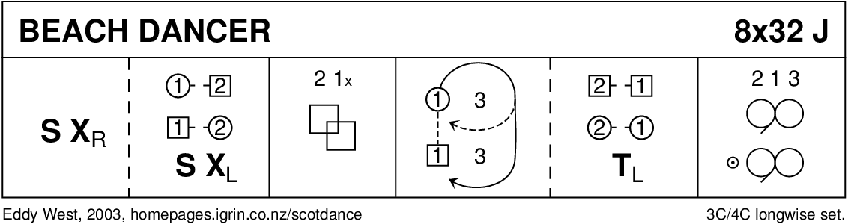

BEACH DANCER (J8x32) 3C (4C set) Eddy West
1- 8 1s set and cross RH, 1s set to 2s on sides and change places LH
9-16 2s+1s dance Ladies' Chain
17-24 1M followed by 1L casts behind 3L and 1M crosses to own side then casts up to 2nd place as 1L dances up middle to 2nd place, (4 bars), 2s+1s turn LH on sides
25-32 1s dance reels of 3 on sides giving RSh to 3s

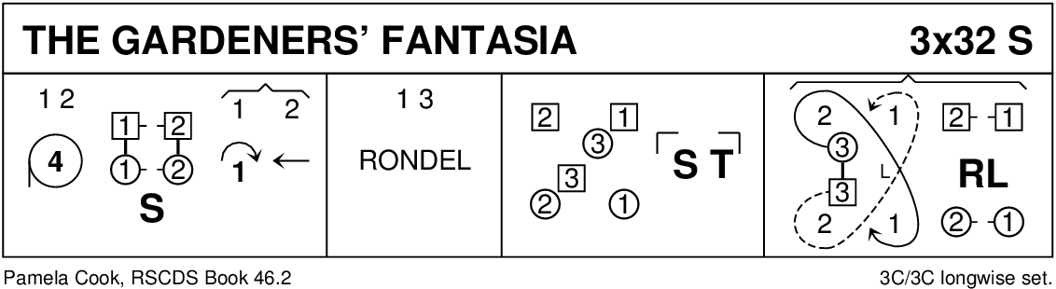

GARDENERS' FANTASIA (S3x32) 3C set Pamela Cook RSCDS Book 46
1- 8 1s+2s circle 4H round to left, 1s facing 2s set and turning inwards cast 1 place to face 3s
9-16 1s+3s dance the Rondel, 1s end in 3rd place and 3s end in 2nd place facing 1st corners
17-24 3s set to and turn corners 3s ending 2nd place opposite sides
25-32 2s+1s dance R&L (begin on sides) while 3s dance up between 2s and cast to 2nd place then lead down LH between 3rd place crossing and cast up to 2nd place. 231
(MINICRIB, Dance Crib compiled by Charles Upton, Deeside Caledonian Society, and his successors)

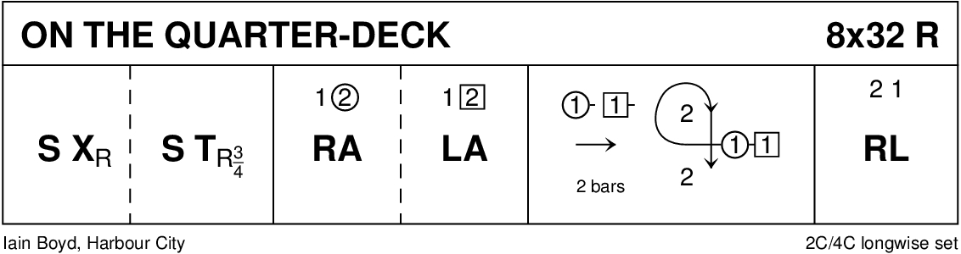

ON THE QUARTER DECK (R8x32) 2C (4C set) Iain Boyd Harbour City
1- 8 1s set and cross over RH, set and ¾ turn RH
9-16 1s dance RH across with 2M and LH across with 2L
17-24 1L followed by 1M dance down for 2 and 1M followed by1L dance up for 2, both cast on Ladies' side and 1M crosses to 2nd place own side
25-32 2s+1s R&L

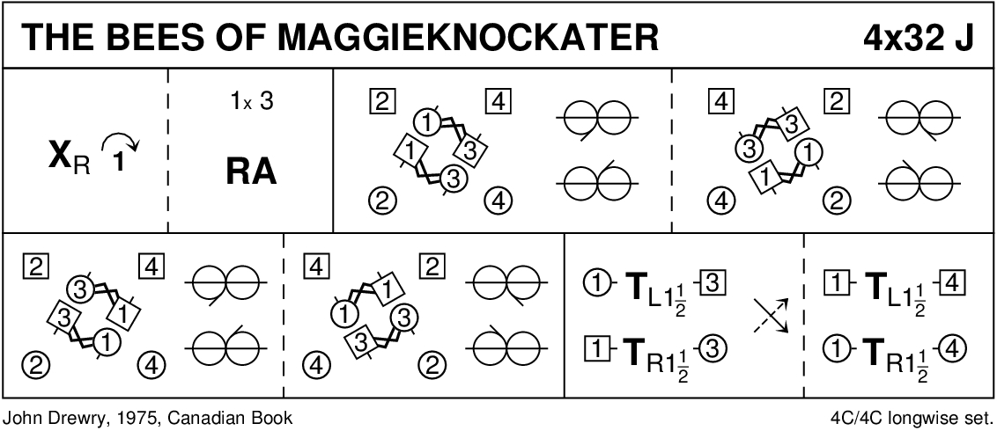

THE BEES OF MAGGIEKNOCKATER (J4x32) 4C set John Drewry Canadian Book
1- 8 1s cross RH and cast 1 place, dance RH across with 3s and end 1M+3L also 1L+3M in prom hold facing out to pass corner person RSh
9-24 All dance 4x½ Reels of 3 on sides (to right to start, then left, right and left) with 1s+3s changing partners in centre at end of each ½ Reel to progress Men clockwise and Ladies anticlockwise. End in centre 1s facing down and 3s facing up
25-32 1s dance between 3s turning 3s with nearer hand 1½ times, crossing over to own sides and turn 4th person 1½ times (Men RH and Ladies LH). 2341

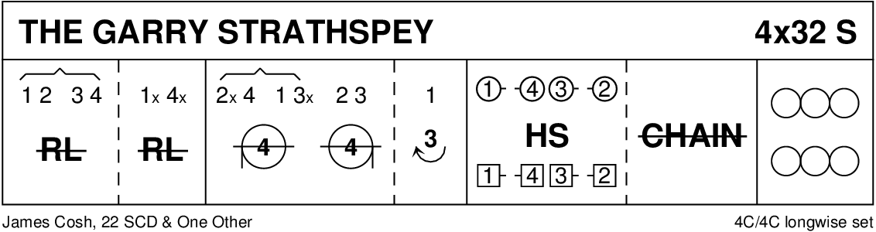

The Garry Strathspey S 4 x 32 bars 4 Couple
1-4 1s2s 3s4s half rights and lefts;
5-8 1s4s half rights and lefts;
9-10 2s4s 1s3s four hands round to the left halfway;
11-12 2s3s four hands round to the right halfway;
13-16 1s lead to the top WHILE 4s3s2s wait for two bars and then step down, finishing 1s 3s facing down, 2s 4s facing up;
17-20 1M4M 1L4L 3M2M 3L2L set (Highland Schottische step);
21-24 all half grand chain;
25-32 2s3s4s1s reels of 4 on own sides.

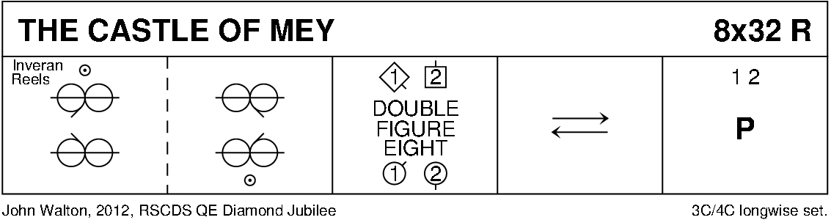

CASTLE OF MEY (R8x32) 3C (4C set) John Walton RSCDS Diamond Jubilee
1- 8 1s dance Inveran reels with 2s+3s
9-16 1s+2s dance double Figs of 8 (1s start by crossing down)
17-24 1s lead down the middle and up, 1s end in middle of the set
25-32 1s+2s dance Poussette

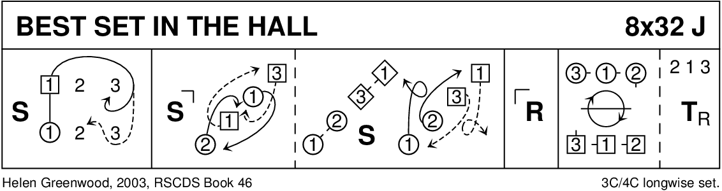

BEST SET IN THE HALL (J8x32) 3C (4C Set) H Greenwood RSCDS Bk 46
1- 8 1s set & 1L followed by partner casts below 3s, 1L crosses & casts up to face her 1st corner while 1M dances up the middle to face 1st corner
9-12 1s set to 1st corners & dance RSh round each other into 3rd corner (pstn) while 1st corners dance in & turn right about to face their original position
13-16 1s+1st crnr person set & 1st crnr persons dance RSh round each other into diag opp crnrs while 1s dance in & pivot to right to face 2nd crnrs
17-24 1s repeat bars 9-16 with 2nd corners & end passing RSh to 2nd place opposite sides. (3)(1)(2)
25-32 2s+1s+3s chase clockwise 1/2 way & turn partners RH

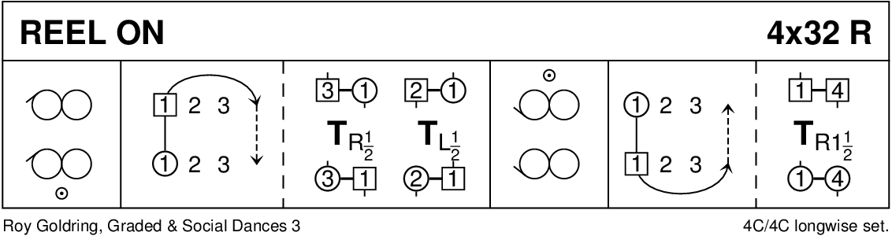

REEL ON (R4x32) 4C set Roy Goldring G & S Dances 3
1- 8 1s dance RSh reels of 3 on sides. 1L ends facing out with partner behind her
9-16 1L followed by partner casts 2 places & cross to opp sides, 3L+1M also 3M+1L change pls RH then 2L & 1M also 2M & 1L change pls LH. (1)2 3 4
17-24 1s dance LSh reels of 3 on sides & 1L ends facing out.
25-32 1L followed by partner casts 2 places & cross to own sides, 1L+4L also 1M+4M turn RH 1.1/2 times. 2 3 4 1

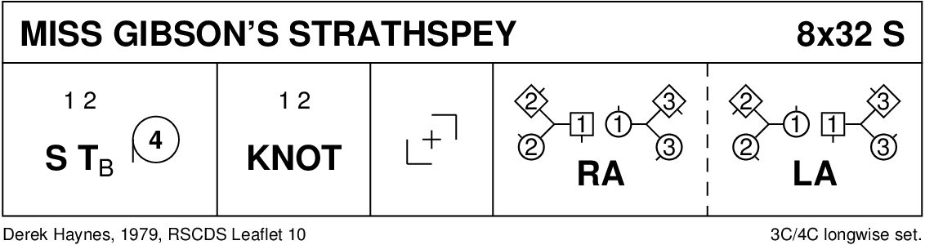

MISS GIBSON'S STRATHSPEY (S8x32) 3C (4C set) Derek Haynes RSCDS Leaflet Dances 18
1- 8 1s+2s set, turn partners 2H opening out into 4H round
9-16 1s+2s dance the Knot, 1s turn LH to end facing 1st corners
17-24 1s turn corners RH, partners LH, 2nd corners RH and partners LH finishing in middle facing opposite sides
25-32 1s dance RH across, (1M with 3s and 1L with 2s), pass partner RSh and dance LH across with other couple, 1s end in 2nd place. 213

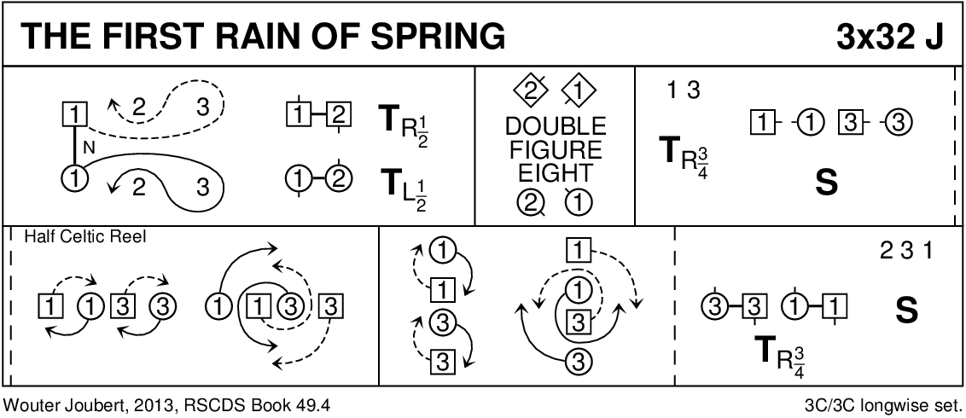

THE FIRST RAIN OF SPRING (J3x32) 3C Wouter Joubert RSCDS Book 49
1- 8 1s dance down, cast up round 3s, meet, dance up to 1st place facing out. 1s+2s ½ turn (Men LH, Ladies RH)
9-16 2s+1s dance double Figs 8 (1s cross up, 2s cast to start)
17-20 1s+3s ¾ turn RH into line up/down in middle facing partner and set
21-28 1s+3s dance ½ Celtic Reel:-
' 21-22 1s+3s pass partner RSh
' 23-24 1M+3L dance clockwise while 1L+3M dance ¾ round each other LSh to face partners in line across
' 25-26 1s+3s pass partner RSh
' 27-28 1L+3M dance clockwise while 1M+3L dance ¾ round each other LSh to face partners in line up/down set
29-32 3s+1s ¾ turn partners RH to side lines and 2s+3s+1s set

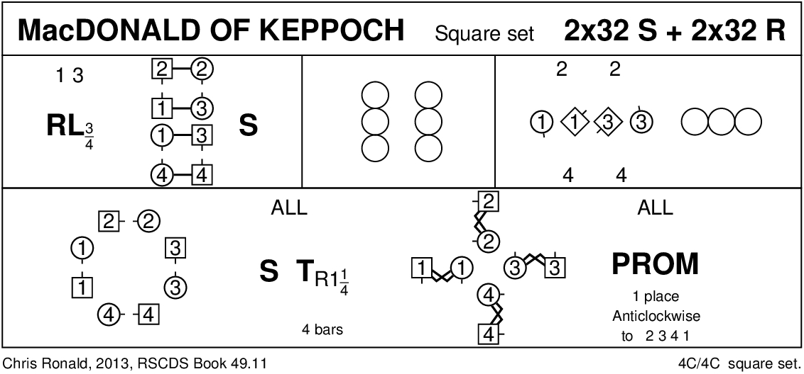

MACDONALD OF KEPPOCH (M-(S64+R64)) Sq.Set Chris Ronald RSCDS Book 49
1- 8 1s+3s dance 6 bars R&L (Men polite turns) to finish in centre B-to-B with partner facing side couples (1L+2L, 1M+4M, 3L+4L, 3M+2M). All set
9-16 Reels of 4 across. Finish in line up/down with Ladies (in middle) facing, 1M facing down, 3M facing up
17-24 Reel of 4 (1L+3L pass RSh)- all pass LSh at ends, RSh in middle. Finish in original places facing partners
25-32 All set, all turn partner RH 1¼ into promenade hold and dance 1 place anticlockwise. Repeat from new positions in Strathspey then twice in Reel time back to original places

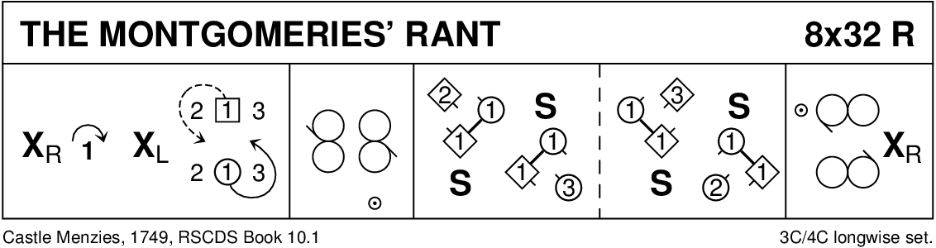

THE MONTGOMERIES' RANT (R8x32) 3C (4C set)
1- 8 1s cross RH and cast down to 2nd place, cross LH and 1L casts up while 1M casts down
9-16 1s dance reels of 3 across, 1L with 2s and 1M with 3s
17-24 1s with nearer hands joined (Lady on Man's left) set to 2L and turn inwards to set to 3M, set to 3L and turn inward and set to 2M
25-32 2s+1s+3s dance reels of 3 on opposite sides 1s giving RSh to 2nd corner, 1s cross RH to 2nd place own sides. 213

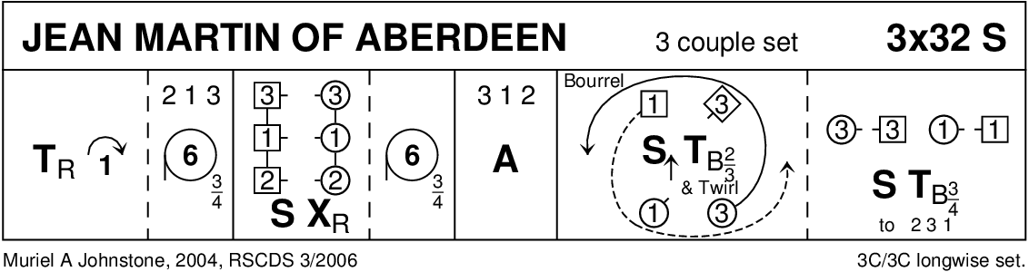

JEAN MARTIN OF ABERDEEN (S3x32) 3C set M Johnstone 3 Dances 2006
1- 8 1s turn RH & cast 1 pl, all circle 6H round 3/4 way to left & end in lines of 3 across (Ladies face down & Men up)
9-16 All set & change places with partner RH, all circle 6H round 3/4 way to left & end in middle facing up. 3 1 2
17-24 All dance Allemande
25-32 1s+3s dance the Bourrel to end 2 3 1 : -
`1M+3L set advg, 3/4 turn 2H & twirl to end BtoB (up/down middle L facing up & M down) while 1L+3M chase anticl’wise 1/2 way to face partner
`1s+3s set to partners & turn 2H to own sides having changed places

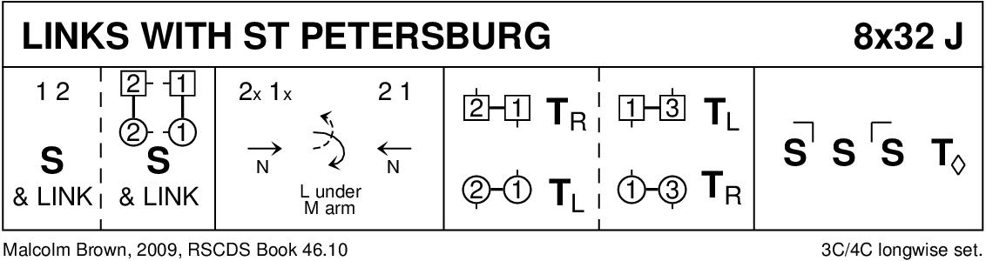

LINKS WITH ST PETERSBURG (J8x32) 3C (4C set) Malcolm Brown RSCDS Book 46
1- 8 1s+2s Set+Link ending 2s facing 1s nearer hands joined, 2s and 1s Set+Link with partners. (2)(1)3
9-16 1s followed by 2s dance down for 3 bars and change places with Lady dancing under Man's arm, 2s+1s dance up to 1st and 2nd places
17-24 2M+1M turn LH as 2L+1L turn RH, 1M+3M turn RH as 1L+3L turn LH and 1s end facing 1st corners
25-32 1s dance 'Hello-Goodbye' setting and petronella turn to 2nd place own sides
(MINICRIB, Dance Crib compiled by Charles Upton, Deeside Caledonian Society, and his successors)

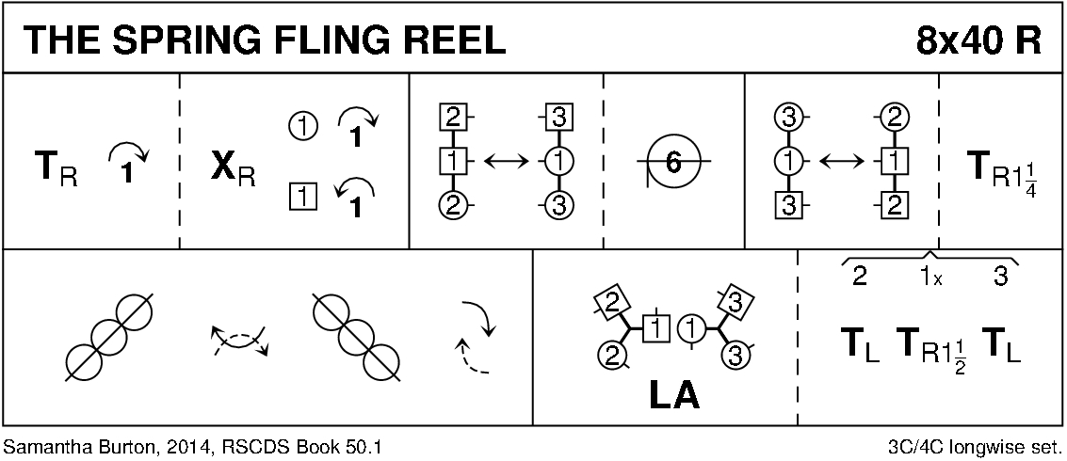

THE SPRING FLING REEL (R8x40) 3C (4C set) Samantha Burton RSCDS Book 50
1- 8 1s turn RH, cast (2s step up bars 3-4), cross RH, cast to Right to 1L between 2s facing down, 1M between 3s facing up
9-16 1L+2s and 1M+3s Adv&Ret, circle 6H ½ round to Left
17-24 1M+3s and 1L+2s Adv&Ret, 1s turn RH 1¼ times to face 1st corners
25-32 1s dance ½ diag reel of 4 with 1st corners, pass RSh, ½ diag reel of 4 with 2nd corners. 1s end in middle 1M below 1L facing own sides
33-40 1L+2s and 1M+3s dance LH across. 1s end 2nd place opposite sides. 2s+3s turn LH while 1s turn RH 1½ times to own side. 213

