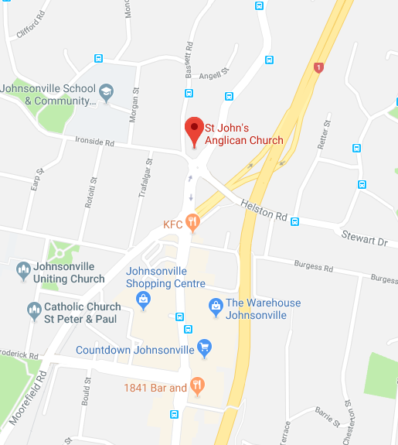
Venue: St John’s Anglican Church Hall,
18 Basset Road, Johnsonville
The church is up a steep drive, and there is plenty of parking at the back of the church.
RSCDS NZ Branch Inc.
Wellington Region

Region Classes 2018

One-day schools over 5 hours
9:30-12:00 and 1:00-3:30

Upper Intermediate – Saturday 21 July
Teacher – Susanna van der Gulik
Advanced – Saturday 18 August
Teacher – Doug Mills

Venue
St John’s Anglican Church Hall, 18 Bassett Road, Johnsonville
(See map on the back)
Registration form
Tear this page off and mail to: Désirée Patterson,
21 Chisbury Street, Churton Park, Wellington 6037
or scan and email to dpatterson@actrix.co.nz
Applications together with payment must be received no later than a week before your class.
Name __________________________________________
Address _______________________________________
________________________________________________
Phone nos. _____________________________________
Email __________________________________________
Emergency Contact (name/phone no.) _______________________________________________
No. of years dancing _____ Club________________
Class applied for _______________________________
PAYMENT to be made to
WELLINGTON REGION, RSCDS NZ BRANCH INC.
- via internet banking to account no. 03 0521 0223533 00
WITH REFERENCE: ‘Reg Class’ + YOUR NAME
And please email Désirée dpatterson@actrix.co.nz to let her know that you have paid online.
- or by cheque
Applicant’s signature ___________________________
Club Teacher’s Signature _______________________
Club Teacher’s Name ___________________________
My payment of $25 is  attached (cheque only, no cash please)
❑ paid online on____/____/2018
Payment received ______/________ /2018
Classes offered
Your teacher must approve the class you have selected.
Upper Intermediate - Saturday 21 July
For dancers who can perform all common steps and formations and have a reasonable level of fitness. Expect to work on teamwork, timing, and tidy dancing!

Advanced - Saturday 18 August
Dancers should expect to work on all aspects of technique to achieve a very high standard of performance. They should have a reasonable level of fitness

Applications together with payment of $25 for the classes must be received no later than a week before your class.
Retain this page for your information

Morning and afternoon tea will be provided. Please bring your lunch or the Johnsonville shops are just a short walk away.

