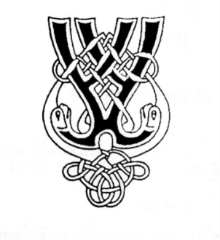
RSCDS NZ Branch Inc. Wellington Region
Region Classes 2021

Two Half Day Classes - 14th August and 11th September
Intermediate Dancers 9.30am - 12.30pm
Advanced Dancers 1.00pm - 4.00pm

Cost: $15 per half day class
(It is best if you attend both classes appropriate for your level. This allows the teacher to build on from the material taught at the first class)
Morning and afternoon tea will be provided. Please bring a water bottle.

Intermediate class
For dancers who are familiar with all common steps and formations and have a reasonable level of fitness. Expect to work on teamwork, phrasing, and formations.
Teacher: Elizabeth Ferguson

Advanced class
For dancers who are able to perform all common steps and formations to a high standard.
Dancers should expect to work on all aspects of technique to achieve a very high standard of performance. They should have a reasonable level of fitness.
Teacher: Ann Oliver

Please check with your club teacher what class is appropriate.
Applications – to be received no later than a week before your first class
Please complete the online registration form by clicking here or go to the website www.wellingtonscd.org.nz

Venue: St David’s Multicultural Church Hall, down the drive off Elizabeth St.
