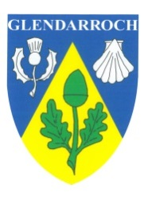
GLENDARROCH SCOTTISH COUNTRY DANCE CLUB
Invites you to our dance on 24th September 2022 at Carlton School Hall, Carlton Avenue, Wanganui
Music by Scottish Saltire Band
Time: 2.00pm – 5.00pm
Admission: RSCDS members $15, non-members $18, spectators and children $5
Raffle
Programme
Andrew and Gordon’s Jig (J) Goldring
The Royal Deeside Railway (R) Book 40
Gramachie (S) Miscellany
Links With St Petersburg (J) Book 46
The Sailor (R) Book 24
The Water of Leith (S) Edinburgh 90th
The Frisky (J) Book 26
The Flowers of Edinburgh (R) Book 1
Fair Donald (S) Book 29
A Capital Jig (J) 5 for 2009
The Pawling Porch (R) Moments in Time
Short Break
Ecclefechan Feline (J) Le Petit Chat Celtique
Back to the Fireside (R) Book 38
Midsummer Common (S) Book 49
The Summer Assembly (R) Book 35
Triple Happiness (S) Book 52
Roaring Jelly (J) Foss, Glendarroch sheets
The De’il Amang the Tailors (R) Book 14

Light Refreshments

