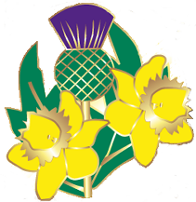
Carterton Scottish Country Dance Club
Saturday 5 November 2022, 7.30 pm
Carterton School Hall, Holloway Street, Carterton
Music by Aileen Logie, Hilary Ferral and Jason Morris
RSCDS Members $10, Non-members $12, Spectators & JAM’s $5

Programme

The Happy Meeting Jig
Catch the Wind Reel
The Haar on Skye Strathspey
Andrew & Gordon’s Jig Jig
On the Quarterdeck Reel
The Water of Leith Strathspey
Pelorus Jack Jig
The Sailor Reel
The Halfway House Strathspey
St Andrew’s Fair Jig
Scott Meikle Reel
Jean Martin of Aberdeen Strathspey
Lonely Sunday Jig
City of Belfast Strathspey
Bill Clement MBE Jig
The Reel of the Royal Scots Reel

Supper

