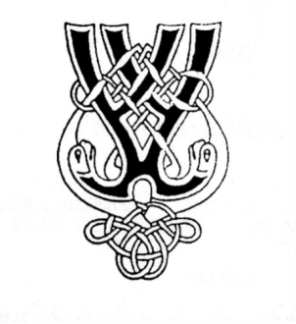
RSCDS NZ Branch Inc. Wellington Region
Region Classes 2023

4 Evening Classes - Intermediate Level
Tuesdays 7.30 – 9.30pm
May 9th, 23rd, June 6th, 20th
Tutor: Susanna van der Gulik
Cost: $35 for all four classes paid when registering; or $10 cash per class
(It is best if you attend all classes. This allows the teacher to develop your skills from those taught at earlier classes)
Please bring a water bottle Live Music

Intermediate Skills
For dancers who are familiar with all common steps and formations and have a reasonable level of fitness. You can dance familiar dances from a briefing and maintain correct footwork, phrasing and hand positions throughout.
You would typically have been dancing for at least 2 years.
Expect to: -
- Improve the accuracy of your steps, including transitions.
- hone technique eg improving teamwork, shape and phrasing.
- integrate the above into some or all of the following formations – Double Triangles, Strathspey Poussette, Turn Corners and Partners, Rondel, Set and Link, Set and Rotate, the Knot, Reel variations…perhaps more.
- dance these within suitable dances.
Please check with your club teacher if you are unsure if Intermediate is the right level for you
Registrations – to be received by May 2 (a week before your first class)
Please complete the online registration form by clicking here or go to the website www.wellingtonscd.org.nz

Venue: St David’s Multicultural Church Hall, down the drive off Elizabeth St.
