Levin Scottish Country Dance Club
Annual Dance
with live music from the SALTIRE SCOTTISH DANCE BAND
July 9th 2023 2.00 – 6.00pm
Ōhau Hall, Muhunoa West Road, Ōhau
(off SH1 about 5.7km South of Levin)

Admission: $18.00
RSCDS members: $15.00
Juniors & Spectators: $5.00

Programme
- New Year Jig J Book 51
2. Shiftin’ Bobbins R Ormskirk
3. City of Belfast S Book 48
- The Laird of Milton’s Daughter J Book 22
*** 5. The Fireworks Reel R Book 48
7. Granville Market J Graded 2
*** 8. Culla Bay S Book 41
9. Mrs Stewart’s Jig J Book 35
10. The Silver Tassie S Bon Accord Book
- The Deil Amang The Tailors R Book 14
Afternoon Tea
- Pelorus Jack J Book 41
12. The Water of Leith S Edinburgh 90
13. The Button Boy R Allanton
*** 14. Beach Dancer J Eddie West
- The Robertson Rant S Book 39
16. Mairi’s Wedding R Cosh
17. Hoopers Jig J Miscellany II
*** 18. Scott Meikle R Book 46
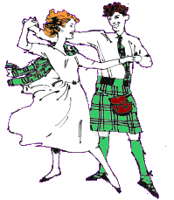
*** Only if you know it (experienced dancers)

Raffles: $2 ticket or 3 tickets for $5

