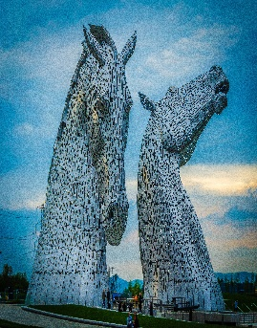
Blenheim Scottish Country Dance Club
70th Birthday Dance
Saturday, 9th May 2026, 5.00 p.m.
Nurses Hall, Service Entrance, Wairau Hospital, Taylor Pass Road, Blenheim
Live Music by Jason & Hillary
Cost $35 (online ANZ 11-7500-0012309-11 Ref your name) or cash at door

J Good Hearted Glasgow Collins SCD

R Shiftin” Bobbins Ormskirk 6

S The Gentleman RSCDS Book 35

J A Diamond for Belfast Belfast Diamond Jubilee Book

R The Castle of Mey RSCDS Diamond Jubilee

S The Rakes of Glasgow RSCDS Book 11

J The Highland Fair Book of Graded SCDs

R Anderson’s Rant MMM1

S 12 Coates Crescent RSCDS Book 40

R Mrs MacLeod RSCDS Book 6

SUPPER

J Lady Catherine Bruce’s Reel Book of Graded SCDs

R The White Cockade RSCDS Book 5

S City of Belfast Belfast Diamond Jubilee Book

J EH3 7AF RSCDS Book 40

R The Meeting of the Waters RSCDS Book 53

S Minister on the Loch 24 G & S Dances

J Napier’s Index RSCDS Book 45

R Trip to Timber Ridge RSCDS Book 52

R Mairi’s Wedding Cosh 22 SCDs

